BACHELORS DEGREE STUDENT SPENDING ANALYSIS DOCUMENTATION
BY
AARON OTOMOFA

Background: This documentation outlines the analysis carried out on the provided dataset. The dataset contains information on students, including demographic information, financial information, and academic information.
Problem statement: The analysis aims to gain insights into the spending habits of universities students and relationships between these variable and to identify trends and patterns in the spending habits of students. It aims at Exploring Student Financial Behaviors.
Objectives: The objectives of this project are;
- To Determine the major with the highest tuition fee
- To determine the major with the highest total expenses (sum of all expenses except tuition).
- To Determine the expenses incurred by each Age group.
- To estimate the income of student in various age groups and levels.
- To investigate the financial strain on the students for effective planning.
- To uncover the most common payment method.
- To uncover the age group of students in the various levels in schools.

DATA DESCRIPTION
Data source:
- Title: Students spending habits
- Provided by: Kaggle
- Date: February, 2025
- Format: CSV.
Data characteristics: The dataset consists of 17 columns and 1000 rows, which are;
- Age: Age of the student (in years)
- Gender: Gender of the student (Male, Female, Non-binary)
- Year in School: Year of study (Freshman, Sophomore, Junior, Senior)
- Major: Field of study or major
- Monthly Income: Monthly income of the student (in dollars)
- Financial Aid: Financial aid received by the student (in dollars)
- Tuition: Expenses for tuition (in dollars)
- Housing: Expenses for housing (in dollars)
- Food: Expenses for food (in dollars)
- Transportation: Expenses for transportation (in dollars)
- Books & Supplies: Expenses for books and supplies (in dollars)
- Entertainment: Expenses for entertainment (in dollars)
- Personal Care: Expenses for personal care items (in dollars)
- Technology: Expenses for technology (in dollars)
- Health & Wellness: Expenses for health and wellness (in dollars)
- Miscellaneous: Miscellaneous expenses (in dollars)
- Preferred Payment Method: Preferred payment method (Cash, Credit/Debit Card, Mobile Payment App

Then, during data cleaning, extra 7 columns were created for efficient analysis. The columns include; Age_group', 'total_income', 'major_expenses', 'minor_expenses', 'total_expenses', 'financially_strained', 'Deficit'.

METHODOLOGY
Data cleaning: The data was cleaned through the following steps;
- Data Import: The data was imported into python lab using panda.
- Checking and removal of duplicates.
- Column Standardization: Column names were renamed, and some columns were dropped for effective analysis.
- Replacing Missing values: missing/empty values were filled using the mean and the appropriate values.
- Creation of extra columns like Age_group', 'total_income', 'major_expenses', 'minor_expenses', 'total_expenses', 'financially_strained', 'Deficit', for effective analysis.
- Data Quality Check: The cleaned data was reviewed for quality and accuracy to ensure readiness for analysis.

Exploratory Data Analysis (EDA): From the dataset, I deduced some key insights which include;
Major count
Biology 228
Economics 204
Computer Science 192
Engineering 192
Psychology 184
This shows the count of students and their various years in college.
year_in_school Counts
Senior 254
Freshman 253
Junior 247
Sophomore 246

This shows the various year in school and the total expenses they tend to incur.
year_in_school Total Expenses
Senior 1816.157480
Freshman 1812.948617
Junior 1789.874494
Sophomore 1760.178862

This shows the Number of Students based on Gender.
count
gender
Male 71
Female 68
Non-binary 53
This shows the Number of Students based on Age group
Age_group
23-25 409
20-22 248
18-20 219

A Correlation analysis was carried out to determine the relationship between the Financial aid and the monthly income, which gave a small but positive correlation of 0.037.

ANALYSIS

- To Determine the major with the highest tuition fee
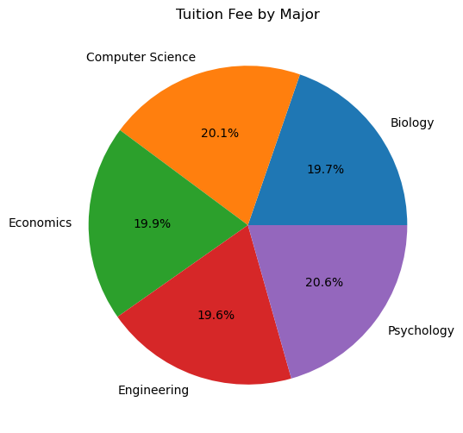

From the dataset, it was discovered after analyzing th Tuition fee for each major;
Engineering has the least average tuition fee, while psychology has the highest.
- To determine the major with the highest total expenses (sum of all expenses except tuition).
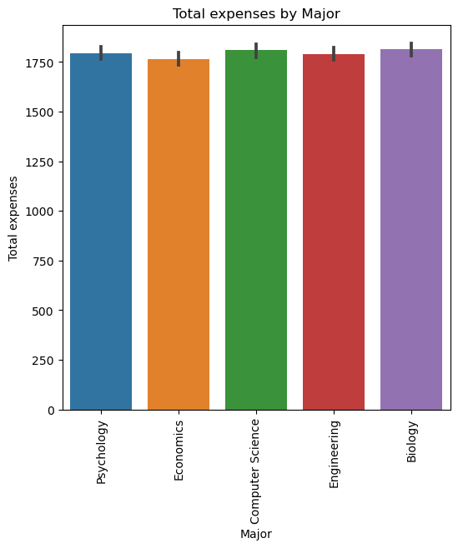
From the analysis above, and from;
major total expenses
0 Biology 1813.653509
1 Computer Science 1809.401042
2 Economics 1765.848039
3 Engineering 1791.203125
4 Psychology 1793.592391
it can be seen that biology incurs the highest total expenses while psychology has the lowest.
- To Determine the expenses incurred by each Age group.

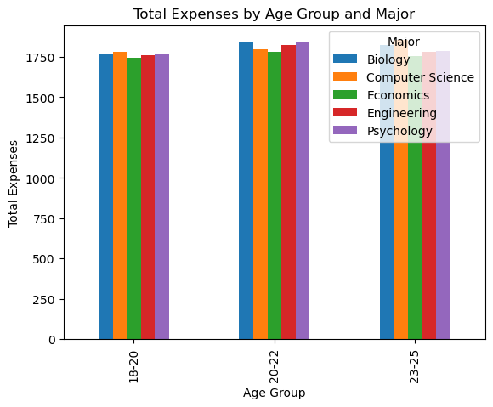
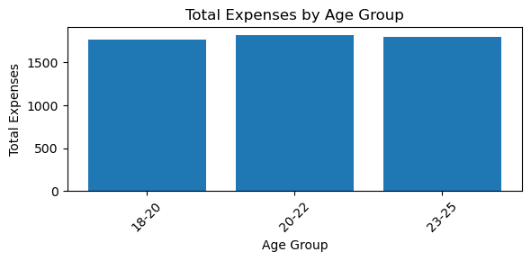
18-20 Biology 1766.134615
1 18-20 Computer Science 1780.121951
2 18-20 Economics 1745.400000
3 18-20 Engineering 1761.189189
4 18-20 Psychology 1768.285714
5 20-22 Biology 1844.450000
6 20-22 Computer Science 1798.500000
7 20-22 Economics 1783.531915
8 20-22 Engineering 1821.311111
9 20-22 Psychology 1840.608696
10 23-25 Biology 1822.333333
11 23-25 Computer Science 1853.513158
12 23-25 Economics 1756.213483
13 23-25 Engineering 1779.195402
14 23-25 Psychology 1786.042857

The above chart shows the distribution of expenses incurred across various age groups and across various age groups and majors.
From the analysis above, the age_group 20-22, incurs the most expenses.
Also, in some certain majors like computer and biology students, 23-25 age group incurs the most expenses.

- To estimate the income of student in various majors, age groups and levels.
- Age_group major total_income
- 0 18-20 Biology 1570.019231
- 1 18-20 Computer Science 1571.634146
- 2 18-20 Economics 1596.750000
- 3 18-20 Engineering 1526.027027
- 4 18-20 Psychology 1493.734694
- 5 20-22 Biology 1513.283333
- 6 20-22 Computer Science 1541.780000
- 7 20-22 Economics 1389.361702
- 8 20-22 Engineering 1559.088889
- 9 20-22 Psychology 1503.782609
- 10 23-25 Biology 1509.149425
- 11 23-25 Computer Science 1494.144737
- 12 23-25 Economics 1545.696629
- 13 23-25 Engineering 1544.436782
- 14 23-25 Psychology 1533.328571

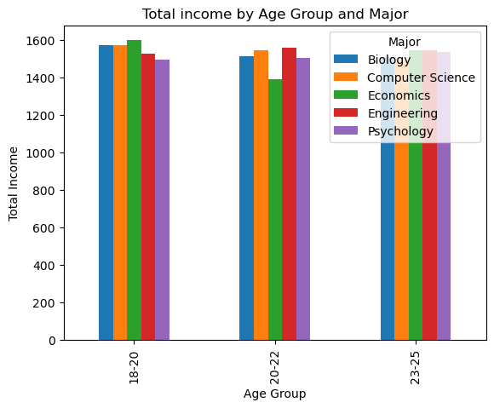
year_in_school total_income
0 Freshman 1561.407115
1 Junior 1521.344130
2 Senior 1526.952756
3 Sophomore 1490.922764
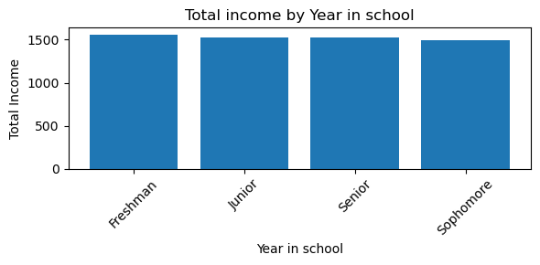
From the above, freshman have the highest income and sophomores have the lowest average income.
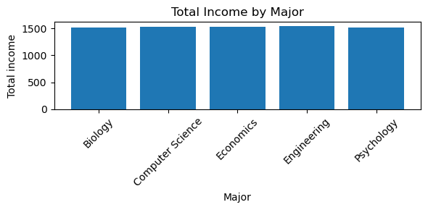
From the above, Engineering major have the highest income.

- To investigate the financial strain on the students for effective planning.
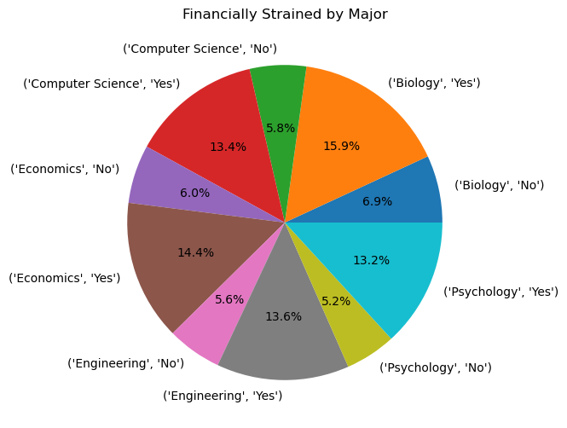

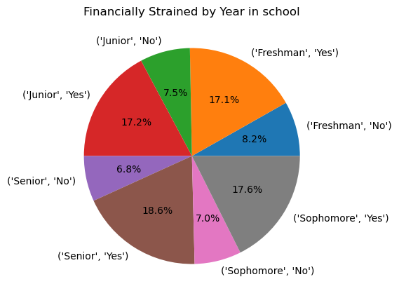

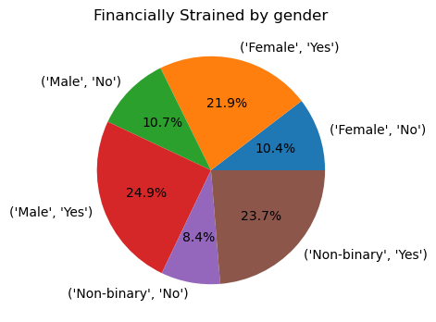

From the above, students in Senior, and 23-25 age group are mostly financially strained.
Also, in gender, male students are mostly financially strained.
NB: financially strained students are those whose total expenses is higher than their total income. With yes being true and No being false.

- To uncover the most common payment method.
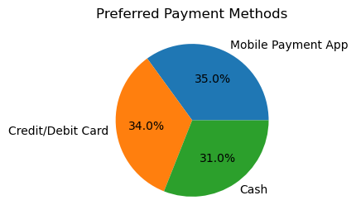
From the above, the most preferred payment method is mobile app payment, followed closely by credit/debit card.

- To uncover the age group of students in the various levels in schools.
- Age_group 18-20 20-22 23-25
- year_in_school
- Freshman 58 63 96
- Junior 63 57 105
- Senior 56 63 99
- Sophomore 42 65 109
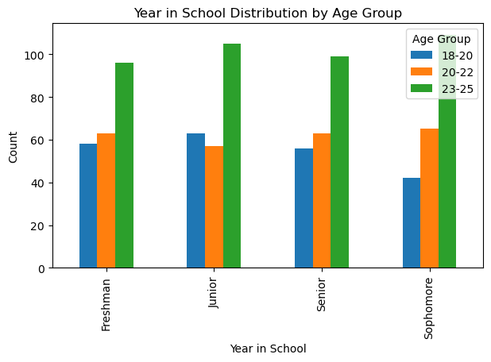
The analysis above shows the age goup of students in the various levels with 23-25 having the most population.
Conclusion
Findings;
- Engineering has the least average tuition fee, while psychology has the highest.
- it can be seen that biology incurs the highest total expenses while psychology has the lowest.
- From the analysis above, the age_group 20-22, incurs the most expenses.
- Also, in some certain majors like computer and biology students, 23-25 age group incurs the most expenses.
- Freshmen have the highest income and sophomores have the lowest average income
- Engineering major students have the highest income..
- Students in Senior, and 23-25 age group are mostly financially strained.
- Also, in gender, male students are mostly financially strained.
- The most preferred payment method is mobile app payment, followed closely by credit/debit card.

Conclusion;
The analysis carried out on the dataset provides insights into the relationships between demographic, financial, and academic variables. The results can be used to inform policy decisions and resource allocation. Further analysis can be carried out to explore other research questions and hypotheses.

